Introduction

to Multimedia

Class vii

Lab 19

**Lab Objectives:**

* What is Multimedia
* Types of Multimedia

What is Multimedia?

Multimedia means that computer information can be represented through audio, video, and animation in addition to traditional media (i.e., text, graphics/drawings, images). Multimedia is the field concerned with the computer controlled integration of text, graphics, drawings, still and moving images (Video), animation, audio, and any other media where every type of information can be represented, stored, transmitted and processed digitally.



***Medium of Communication***

***Many or more than one***

**Media**

**Multi**

The Basic Elements of Multimedia



1. **Text**



1. **Graphic**

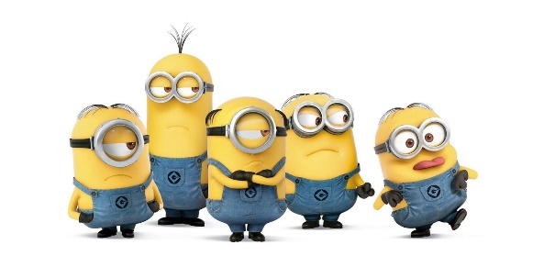

1. **Animation**



1. **Video**

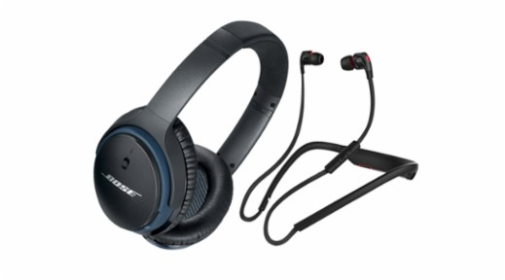

1. **Audio**

Text

* A broad term for something that contains words to express something.
* Text is the most basic element of multimedia
* A good choice of words could help convey the intended message to the users (keywords).



Fig: Using Multimedia Texting for communications

Graphic

* Could be produced manually (by drawing, painting, carving, etc.) or by computer graphics technology
* Used in multimedia to show more clearly what a particular information is all about (diagrams, picture)

Fig: Graphical Presentation of Conversation

Animation

* The illusion of motion created by the consecutive display of images of static elements
* In multimedia, animation is used to further enhance / enriched the experience of the user to further understand the information conveyed to them.

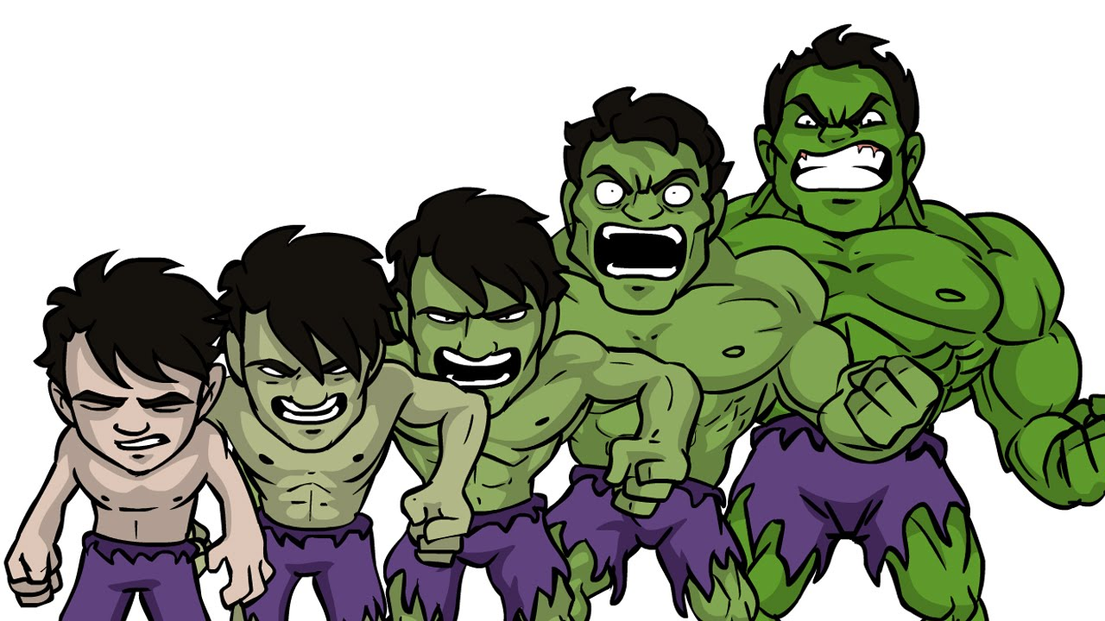

Fig: Motion of graphics (animation)

Audio

* Produced by vibration, as perceived by the sense of hearing
* In multimedia, audio could come in the form of speech, sound effects and also music score

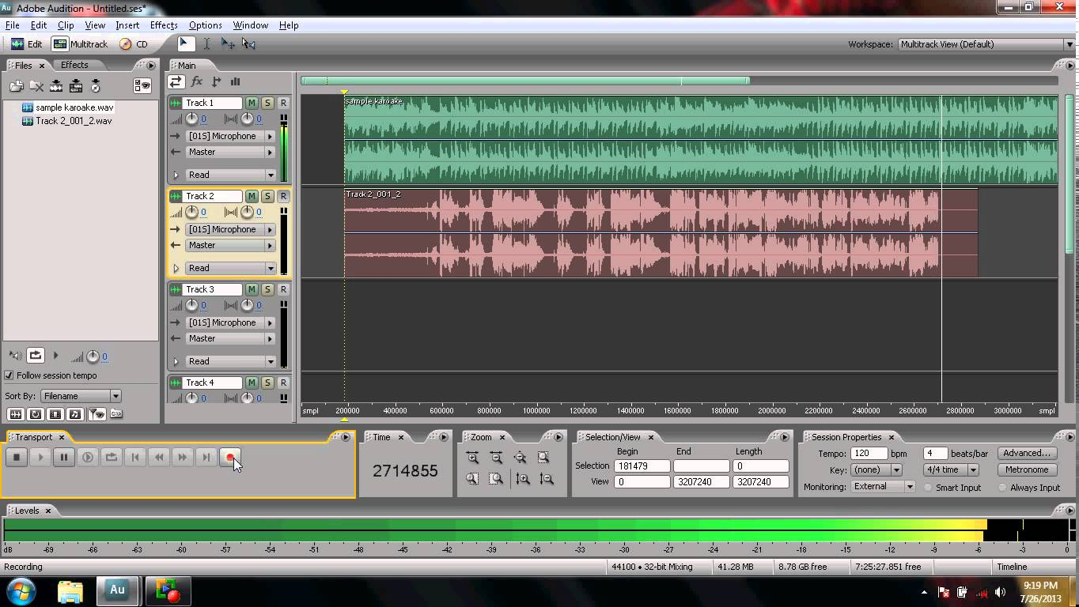

Fig: Production of Music (Audio)

Video

* This is the technology of capturing, recording, processing, transmitting, and reconstructing moving pictures
* Video is more towards photo realistic image sequence / live recording as in comparison to animation
* 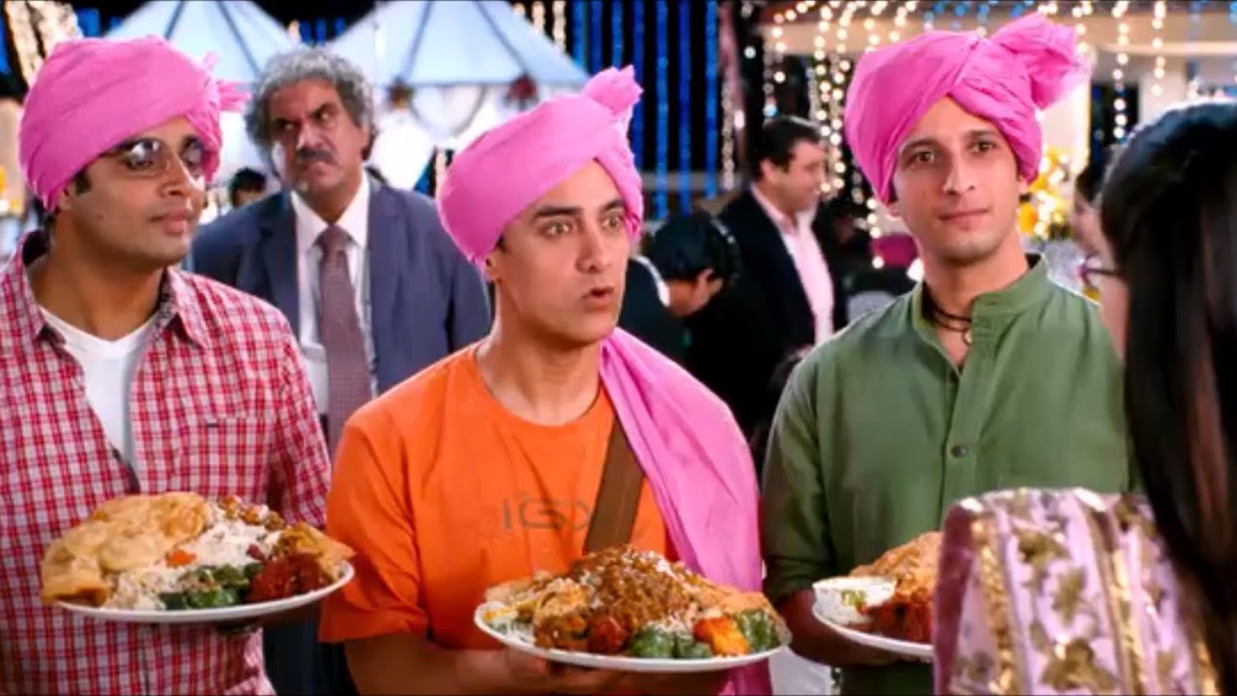Video also takes a lot of storage space. So plan carefully before you are going to use it.

Fig: Screen Shot from the movie ‘3 Idiots’ Video